ADRIAN TURION |  | Avenue de Sainte-Clotilde 9  1205 Geneva, Switzerland | 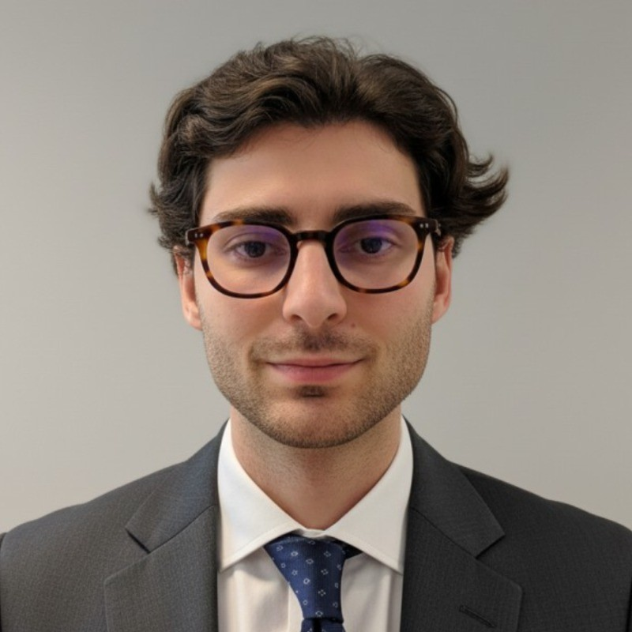
turionadrian@gmail.com | Swiss | 10.11.2000 |  | +41 77 262 37 96
INTRODUCTION
Execution-focused MSc Finance candidate with cross-border transaction experience across Europe, US, and Asia, seeking to join XTS Commodities' trading desk. Strong quantitative and risk management background from active options trading and financial modeling across 10+ concurrent mandates. Proven ability to deliver under tight deadlines in fast-paced, international environments.
WORK EXPERIENCE
Auraïa Capital Advisory – Small & Mid Cap Cross-border M&A Boutique  Mergers & Acquisitions Analyst (Converted internship into full-time position) |  | Geneva, Switzerland  Aug 2024 – Current
- End-to-end execution exposure in a lean 3-person deal team across 10+ live mandates spanning sourcing, valuation, due diligence, negotiations, and closing with deal values ranging from EUR 5M to EUR 50M across healthcare, tech, and life sciences
- Conducted comprehensive industry research and identified strategic buyers for cross-border deals spanning Europe, US, and Asia, maintaining buyer universes and coordinating data room management across multiple concurrent mandates
- Managed relationships with clients, advisors, and counterparties throughout transaction lifecycles, coordinating seamlessly with legal, tax, and accounting teams across Europe, US, and Asia to structure and close cross-border deals

RC Group – Currently under LBO with Crédit Mutuel Equity  Mergers & Acquisitions Intern |  | Paris, France  Feb 2024 – Aug 2024
- Conducted financial and operational due diligence on acquisition targets with revenues of EUR 10M-30M, analyzing market trends and competitive landscape while building financial models to assess synergies and post-acquisition value creation opportunities

Europ Assistance – Subsidiary of Generali Insurance  Financial Analyst Intern |  | Geneva, Switzerland  Apr 2023 – Aug 2023
- Built automated financial dashboards in Excel and PowerBI tracking KPIs for the Swiss subsidiary (CHF 50M+ revenues), performed variance analysis on monthly P&L, and developed cost allocation models to improve profitability analysis by service line

LEADERSHIP
- Led AIESEC financial recovery by sourcing corporate leads and negotiating partnerships, closing 3 key deals generating CHF 60K annual revenue and increasing volunteer placements by 40%
- Manage a diversified investment portfolio using Cash Secured Puts and Covered Calls, generating +8% annualized returns through disciplined theta decay strategies with 45-day expiries
- Finalist in 2024 McKinsey-sponsored case competition, presenting a data-driven model to forecast market events using order book data with potential CHF 200K annual revenue impact
EDUCATION
HEC Lausanne  Master of Science in Finance |  | Lausanne, Switzerland  2021 – 2024
- Cumulative GPA: 5.2/6.0 (Top 15% of the class cohort)
- Exchange programs at Waseda University (Tokyo, Japan) and Maastricht University (Maastricht, Netherlands)
- Relevant Coursework: International Finance, Risk Management, Investment and Portfolio Management
- Thesis Topic: Synergies Analysis of the Merger between American Airlines & US Airways

Bachelor of Science in Management |  | 2018 – 2021
- Cumulative GPA: 4.7/6.0

Scientific Baccalaureate with Highest Honors (16.6/20) |  | Aix-en-Provence, France
ADDITIONAL INFORMATION
Languages:  Computer:  Interests:  References: | French (Native, C2), Spanish (Native, C2), English (Fluent, C1), German (Business proficient, B2-C1)  Financial Modeling, Risk Management, Market Analysis | Python, Bloomberg, Excel/VBA  Geopolitics, Badminton (Provence regional finalist), Gym, Real use cases of Artificial Intelligence  Guillaume Arnaldez – Ex-Director at Auraïa Capital Advisory, guillaume.arnaldez@auraia.ch  Sacha Caravatti – CFO at Europ Assistance Switzerland, scaravatti@europ-assistance.ch

